**1 Introduction**

**1.1 Purpose**

This Software Requirements Specification (SRS) is intended to delineate software requirements for the user’s collection tracking system. This SRS is intended to provide guidance to the developers of the system to implement required functionality, as well as the test team to develop appropriate Verification and Validation (V&V) plans and procedures required to demonstrate to the customer that the system was built to this specification.

**1.2 Scope**

This document specifies the requirements for the following capabilities.

1. Collection tracker user interface
2. Marketplace listings and capabilities
3. Profile capabilities
4. In-application clerk and payment capabilities
5. Admin control and management of marketplace listings

**1.3 Definitions**

Table 1 Acronyms and Definitions

BDD: Block Definition Diagram.  
IA: Information Assurance.  
IP: Internet Protocol.  
SRS: Software Requirements Specification.  
STIGS: Security Technical Implementation Guides. TCP: Transmit Control Protocol.

UDP: User Datagram Protocol.

UML: Unified Modeling Language.

V&V: Verification and Validation.

**1.5 Overview**

This document follows the recommended format specified in IEEE Std 830-1998 IEEE

Recommended Practice for Software Specifications. For Section 3, the specific template A.5 for organizing information by feature is followed.

**2 Overall Description**

**2.1 Product Perspective**

The Collection Tracker system is intended to be a verified marketplace and sharing platform to sell collection items online. This document specifies capabilities for an admin to monitor and control the system. The document describes capabilities that are hosted by a separately defined system. Figure 1 System Block Diagram shows the system overview, using a Unified Modeling Language (UML) Block Definition Diagram (BDD).

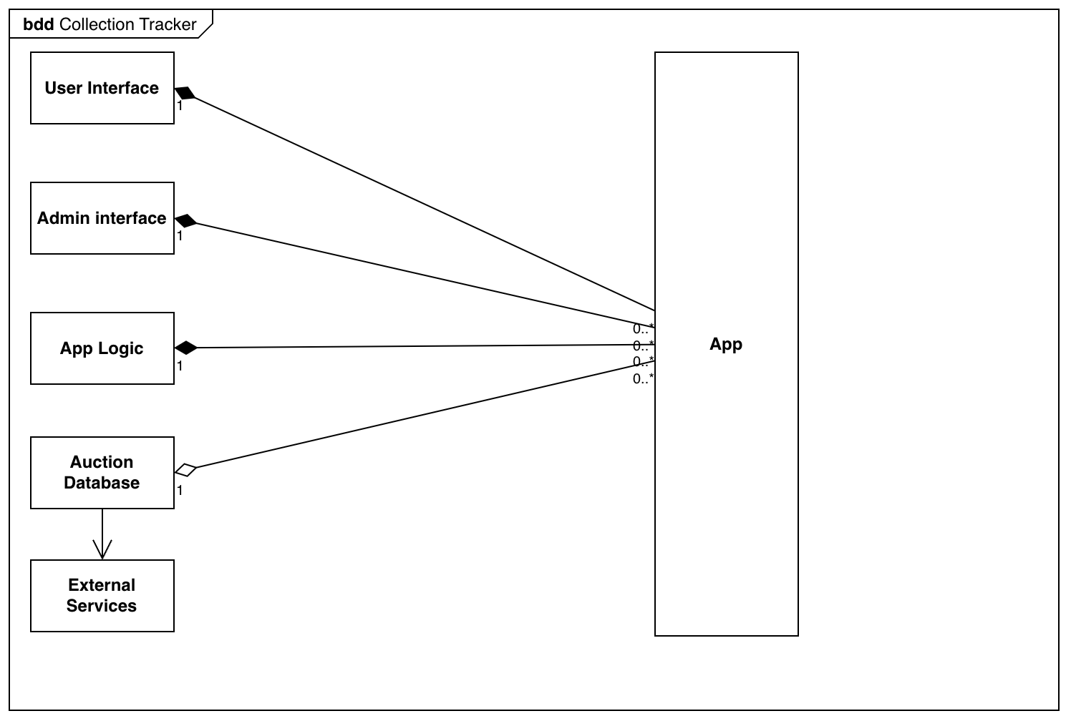

**Figure 1 System Block Diagram**

**2.2 Product Functions**

The following use case diagram depicts the users of the system, and the intended way in which they will interact with the system.

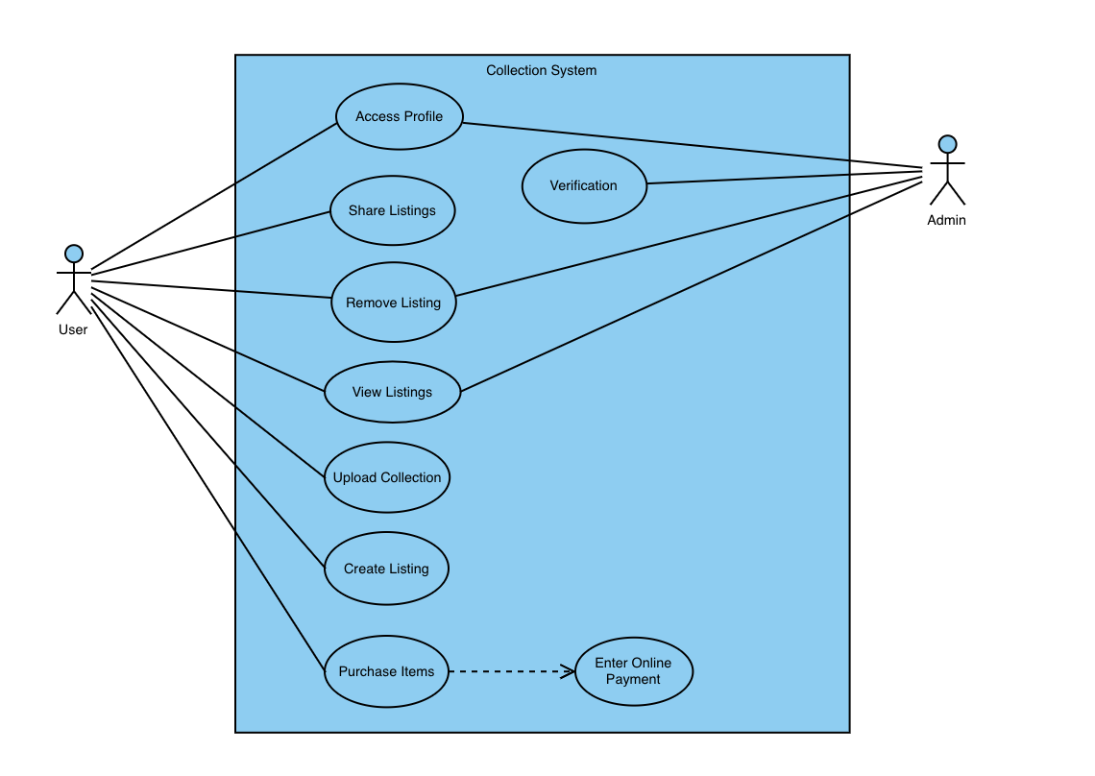

**Figure 2 Collection Tracker Use Cases**

**2.3 Use Case Descriptions**

**2.3.1 Access Profile**

| **General Characteristics** |  |
| --- | --- |
| Intent | Create a personal user profile |
| Scope | * User Name * Display Name * Real Name? * Customer Rating * Listings * Contact information * Change password * Profile Picture * Location * Reviews * Number of successful transactions |
| Primary Actor | User |
| Secondary Actors | Admin |
| Preconditions | * Valid username and password input |
| 2.3.4 Assumptions | * Has a valid account * Has internet |
| Trigger | * User clicks “My Profile” |
| Success Post Condition | * Directs user to their profile |
| Failed Post Condition | * User unable to access profile |

**Sunny Day Scenario**

| Step | Action |
| --- | --- |
| Start | This scenario begins with the User having already created a profile. |
| 1 | There is an area within the application that directs the user to their profile. Will be labeled either “My Profile” or “My Account” or some variation |
| 2 | When user clicks onto the icon/button, the app directs the user to their own profile |
| 3 | User is shown multiple options, including “Edit Profile”, “Change Password”, etc. |
| 4 | This use case ends when the user clicks out of their profile and into a different use case |

**Rainy Day Scenario**

| Step | Action |
| --- | --- |
| Start | **This scenario begins with a failure to access their profile** |

**2.3.2 Share Listings**

| **General Characteristics** |  |
| --- | --- |
| Intent | Allow user to sell items in their collection |
| Scope | Collection Tracker |
| Primary Actor | User |
| Secondary Actors | Admin |
| Preconditions | * User has items in their collection * Bank account or card connected |
| 2.3.4 Assumptions | * Internet connection |
| Trigger | User attempts to sell an item |
| Success Post Condition | User shares the listing |
| Failed Post Condition | User is unable to share the listing |

**Sunny Day Scenario**

| Step | Action |
| --- | --- |
| Start | This scenario begins when the user attempts to share a listing on the app., |
| 1 | The user is asked how they would like to share the listing |
| 2 | The user selects their method of sharing |
| 3 | The user is prompted to share the listing |
| 4 | This use case ends when the user successfully shares the listing |

**Rainy Day Scenario**

| Step | Action |
| --- | --- |
| Start | **This scenario begins with a failure to share the listing, whether through cancellation or other means** |

**2.3.3 Upload Collection**

| **General Characteristics** |  |
| --- | --- |
| Intent | Allows User to display their collection, with verification that the items are real |
| Scope | * Collection lists * Value of individual lists * Value of total inventory * Upload a new item into the collection * Add tags to organize/sort the collections * Verify the collection * Compare collections * View collections |
| Primary Actor | User |
| Secondary Actors | Admin |
| Preconditions | * Has created a profile |
| 2.3.4 Assumptions | * User has a valid and verified profile * User has a collection to be made |
| Trigger | * User clicks “Collections” tab |
| Success Post Condition | * The user is directed to a list of their collections |
| Failed Post Condition | * The user is unable to retrieve a list of their collections |

**Sunny Day Scenario**

| Step | Action |
| --- | --- |
| Start | The scenario begins when the user tries to access their collections |
| 1 | The user is prompted with a list of his collection, each detailing their respective value |
| 2 | When the user clicks into one of their collections, it will allow the user to view the entire contents of their collection, as well as an option to add an item to their collection |
| 3 | When the user is finished looking at their specific collection, they are able to go back and have the option to manipulate their collections, either by sorting, deleting, or adding a collection. (Note: this option is also available before the user clicks into a private collection) |
| 4 | This scenario ends when the user clicks onto another use case |

**Rainy Day Scenario**

| Step | Action |
| --- | --- |
| Start | **The scenario begins when the user is unable to access their collection.** |

**2.3.4 Create Listing**

| **General Characteristics** |  |
| --- | --- |
| Intent | Allow user to create a listing from an item in their collection |
| Scope | Collection Tracker |
| Primary Actor | User |
| Secondary Actors | Admin |
| Preconditions | User has the item in their collection |
| 2.3.4 Assumptions | * Connected to internet |
| Trigger | Successful login of Use Case access profile |
| Success Post Condition | Listing is created from the item |
| Failed Post Condition | Listing is not created from the item |

**Sunny Day Scenario**

| Step | Action |
| --- | --- |
| Start | This Scenario begins when the user begins to create a listing |
| 1 | The user is instructed by the User Interface to pick which item is going to be listed |
| 2 | The user is instructed by the User Interface to pick how many items they want to be listed |
| 3 | The user is instructed by the User Interface to pick the time which they want the listing posted |
| 4 | This Use Case ends when 1) the user clicks submit to post their listing, or when there is an error |

**Rainy Day Scenario**

| Step | Action |
| --- | --- |
| Start | This Scenario begins with a failure if the user does not have the item or amount of items in their profile |

**2.3.5 View Listing**

| **General Characteristics** |  |
| --- | --- |
| Intent | Allows the user to view all of their listings, or view a specific listing |
| Scope | * Price * Picture * verified/not verified * Description * share |
| Primary Actor | * user |
| Secondary Actors | * admin |
| Preconditions | * The user has a valid account, with the item they are trying to sell in their collections. * The item has to be verified to be legit * User has set a price * User has a picture |
| 2.3.4 Assumptions | * User is connected to the internet * User has already created a listing * They are trying to view their listing |
| Trigger | * User clicks view listing |
| Success Post Condition | * The user is able to successfully look at their listing |
| Failed Post Condition | * The user is unable to view their listing |

**Sunny Day Scenario**

| Step | Action |
| --- | --- |
| Start | The scenario begins when the user tries to view their listing by clicking a button labeled “View Listing” or some variation |
| 1 | Assuming all conditions met, they are able to view their listing |
| 2 | If the user would like to edit their listing, they can do this by clicking the button on their listing labeled “Edit listing” |
| 3 | This scenario ends when the user either saves their changes and clicks away from the listing, or redirects to another use case |

**Rainy Day Scenario**

| Step | Action |
| --- | --- |
| Start | **This scenario begins when the user is unable to view their listing** |

**2.3.5 Purchase Items**

| **General Characteristics** |  |
| --- | --- |
| Intent | Allow user to purchase an item or items from a listing |
| Scope | Collection Tracker |
| Primary Actor | User |
| Secondary Actors | Admin |
| Preconditions | Item is listed on the marketplace and is verified by admin |
| 2.3.4 Assumptions | Internet connection |
| Trigger | User purchases an item off the market place |
| Success Post Condition | User is able to purchase item |
| Failed Post Condition | User is unable to purchase item |

**Sunny Day Scenario**

| Step | Action |
| --- | --- |
| Start | This scenario begins when the user tries to purchase an item |
| 1 | The user is given a choice on the listing whether they would like to immediately buy it or place an offer |
| 2 | The seller is able to contact the user regarding their offer, with choices to accept, decline, or counteroffer. |
| 3 | If the seller accepts, they can either plan a time to meet up or mail it to them, giving them the tracking number as well. |
| 4 | This scenario ends when the user successfully purchases an item or clicks onto another use case |

**Rainy Day Scenario**

| Step | Action |
| --- | --- |
| Start | **This scenario begins when the user is unable to purchase an item** |

**2.3.6 Verification**

| **General Characteristics** |  |
| --- | --- |
| Intent | Once uploaded an item into their collection, it must be verified by some means. |
| Scope | * Verification method * item |
| Primary Actor | user |
| Secondary Actors | admin |
| Preconditions | * The user has a valid account * The user has a valid collection they would like to add their item into * The user has a valid method of verification |
| 2.3.4 Assumptions | * The user has a valid account * The user has a valid collection * The user has a valid method of verification |
| Trigger | * User tries to verify their uploaded item |
| Success Post Condition | * The user successfully verifies their item |
| Failed Post Condition | * The user is unable to successfully verify their item with a reason stating why not. |

**Sunny Day Scenario**

| Step | Action |
| --- | --- |
| Start | This scenario begins when the user wants to verify their item |
| 1 | They are redirected to a page where the user can input all the information regarding their item |
| 2 | The user is prompted to show proof that the item has been verified as legit |
| 3 | The scenario ends when the user successfully verifies their item |

**Rainy Day Scenario**

| Step | Action |
| --- | --- |
| Start | **This scenario begins when the user is unable to verify their item, whether it be unreadable proof or some other reason** |

**2.3.7 Remove Listing**

| **General Characteristics** |  |
| --- | --- |
| Intent | Allow the User to remove listing from the marketplace |
| Scope | Collection Tracker |
| Primary Actor | User |
| Secondary Actors | Admin |
| Preconditions | User has added a listing to the marketplace/admin cannot verify the listing |
| 2.3.4 Assumptions | Has a valid account and internet connection |
| Trigger | Created a listing on the market/unverified listing |
| Success Post Condition | Listing is removed from the marketplace |
| Failed Post Condition | Listing has already been sold/unable to be removed |

**Sunny Day Scenario**

| Step | Action |
| --- | --- |
| Start | This scenario begins when the user navigates into one of their listings |
| 1 | The user is prompted with several options, one of which is the remove listing option. |
| 2 | If the button is clicked, the user is prompted with a warning, making sure that the user would like to remove the listing |
| 3 | The scenario ends when the user is notified that their item has successfully been removed from the marketplace |

**Rainy Day Scenario**

| Step | Action |
| --- | --- |
| Start | **The scenario begins when the user is unable to remove their listing** |

**2.3.8 Enter Online Payment**

| **General Characteristics** |  |
| --- | --- |
| Intent | Enter online payment info for purchasing an item off marketplace |
| Scope | Collection Tracker |
| Primary Actor | User |
| Secondary Actors | Admin |
| Preconditions | User has selected to purchase an item off the marketplace |
| 2.3.4 Assumptions | Internet connection |
| Trigger | User is approved to purchase an item off the market |
| Success Post Condition | User online payment info is correct and item is paid for |
| Failed Post Condition | User online payment info is incorrect and order is canceled. |

**Sunny Day Scenario**

| Step | Action |
| --- | --- |
| Start | This scenario begins when the user is either paying for an item they have purchased, or manually directing to their profile to input their payment method |
| 1 | The user is prompted to select their method of payment |
| 2 | The user is then prompted to input any information relating to that payment method |
| 3 | The user is asked if they would like to save their payment information for future purchases |
| 4 | The scenario ends when the user successfully registers their payment information |

**Rainy Day Scenario**

| Step | Action |
| --- | --- |
| Start | **This scenario begins when the user is unable to add a payment method** |

**3 Specific Requirements**

**3.3 System Features**

**3.3.1.1 Purchase Item**

3.3.1.1.1 Introduction/Purpose of Feature

This feature enables users to purchase an item on the marketplace. Users can bid for the final price. Users can see details of the item they are purchasing such as description, price, and seller information and score.

3.3.1.1.2 Stimulus/Response Sequence

The following is the sequence of actions that occur during the "Purchase Item" use case:

3.3.1.1.3 View Listings

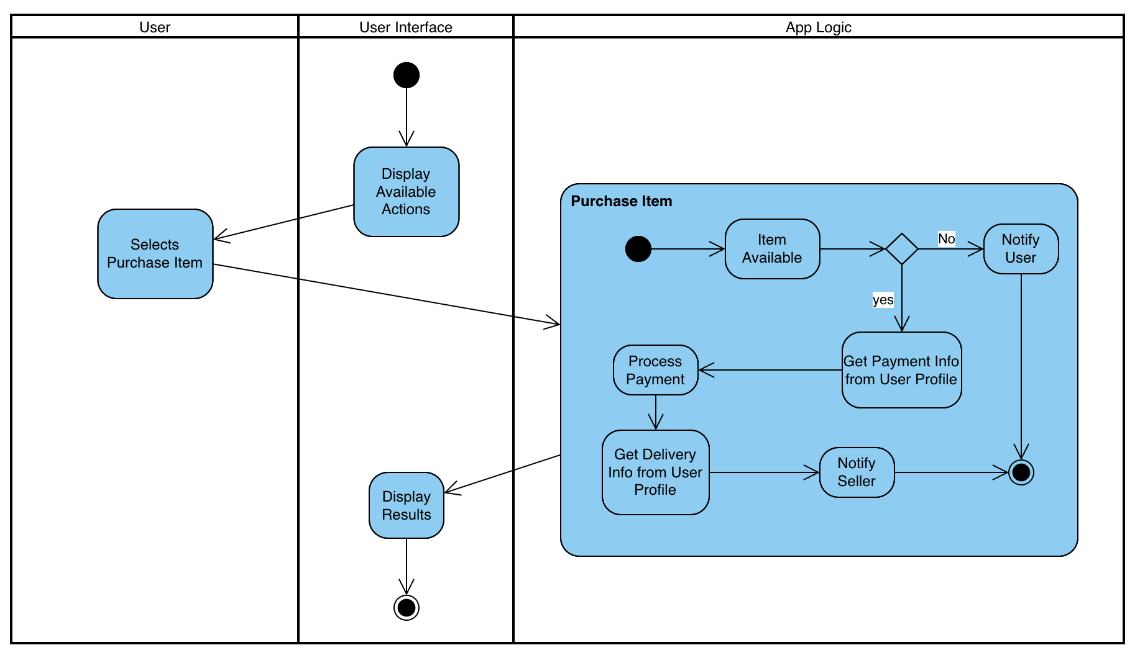

**Figure 3 Purchase Item Activity**

3.3.1.1.4 Associated Functional Requirements

The following functional requirements are associated with the "Purchase Item" use case:

3.3.1.1.4.1 Users **shall** have the ability to contact the seller of the item they are purchasing.

3.3.1.1.4.2 The system **shall** provide a user-friendly interface for users to purchase, contact sellers, and favorite the item.

3.3.1.1.4.3 Users **shall** have the option to cancel their purchase within a time frame allotted by the seller.

3.3.1.1.4.4 Users **shall** be able to compare the prices of similar items.

3.3.1.1.4.5 Users **shall** have the ability to view their items they saved for later and see if they have gone on sale.

**3.3.1.2 Create Listing**

3.3.1.2.1 Introduction/Purpose of Feature

This feature enables users to create a listing on the marketplace. Users can post items they want sold. Users can set the price and description of an item. Items listed can be named by the user. Items can be given a quantity of how many are available.

3.3.1.2.2 Stimulus/Response Sequence

The following is the sequence of actions that occur during the "Create Listing" use case:

3.3.1.2.3 Create Listing

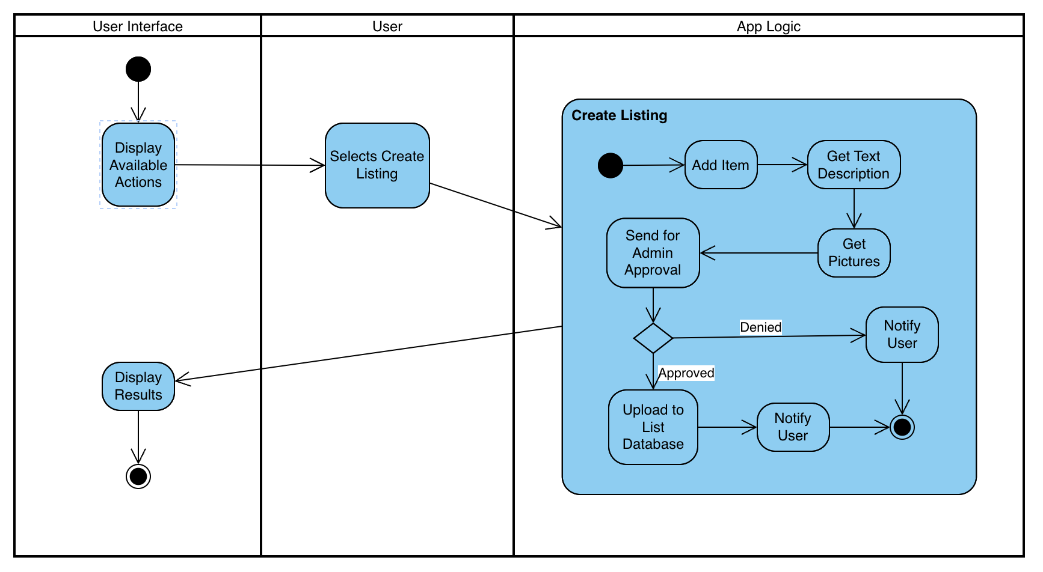

**Figure 4 Create Listing Activity**

3.3.1.2.4 Associated Functional Requirements

The following functional requirements are associated with the "Create Listing" use case:

3.3.1.2.4.1 Users **shall** have the ability to set the price of their item.

3.3.1.2.4.2 The system **shall** provide a user-friendly interface for users to create and describe their item.

3.3.1.2.4.3 Users **shall** have the option to remove their listing off the marketplace.

3.3.1.2.4.4 Users **shall** be able to make the item listing public or private whenever they choose to.

3.3.1.2.4.5 Users **shall** have the ability to view their items they have listed.

3.3.1.2.4.6 Users **shall** have the ability to see the amount of views their item has gotten.

3.3.1.2.4.7 The system **shall** give the user a view on whether their item is public or private.

**3.3.1.3 View Listings**

3.3.1.3.1 Introduction/Purpose of Feature This feature enables users to view listings of items available in the marketplace. Users can explore details about items for sale, including item descriptions, prices, and seller information. It provides a comprehensive view of available items for potential buyers.

3.3.1.3.2 Stimulus/Response Sequence

The following is the sequence of actions that occur during the "View Listings" use case:

3.3.1.3 View Listings

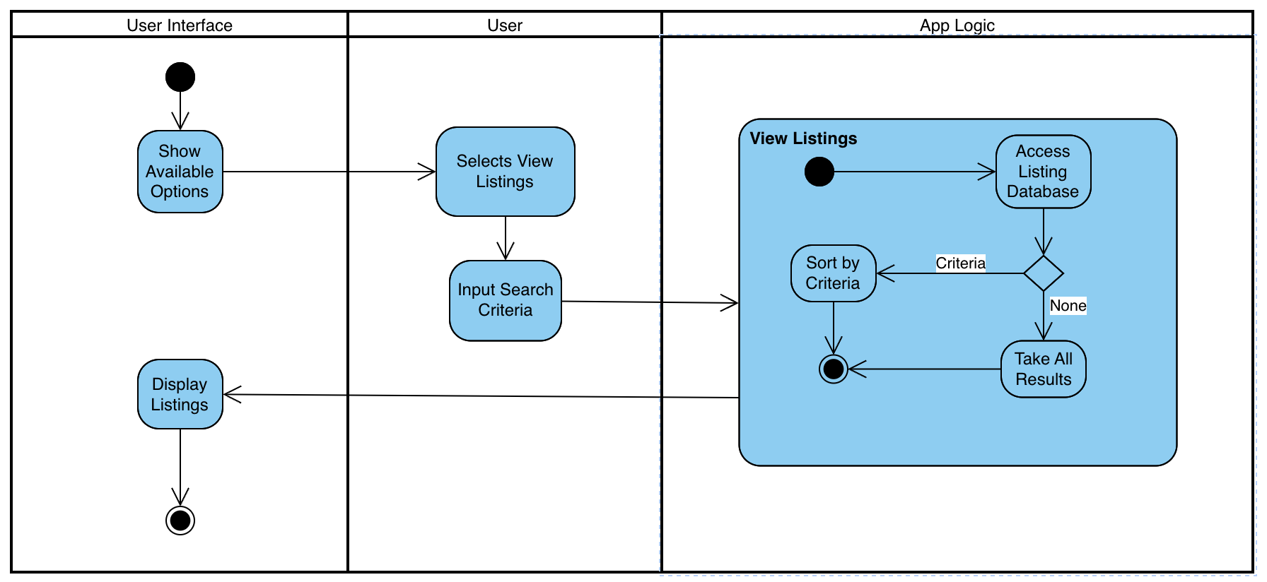

Figure 5 View Listing Activity

3.3.1.3.3 Associated Functional Requirements

The following functional requirements are associated with the "View Listings" use case:

3.3.1.3.3.1 The system **shall** provide a user-friendly interface for users to browse and search marketplace listings.

3.3.1.3.3.2 Users **shall** be able to filter listings based on criteria such as item category, price range, and seller ratings.

3.3.1.3.3.3 The system **shall** display detailed information for each listing, including item descriptions, prices, and seller profiles.

3.3.1.3.3.4 Users **shall** have the option to click on a listing to view additional details and initiate a purchase.

**3.3.1.4 Upload Collection**

3.3.1.4.1 Introduction/Purpose of Feature This feature allows users to upload their collection of items to the system, showcasing their collection to potential buyers. Users can provide details about each item, add tags for organization, and verify the authenticity of their collection.

3.3.1.4.2 Stimulus/Response Sequence

The following is the sequence of actions that occur during the "Upload Collection" use case:

3.3.1.4 Upload Collection

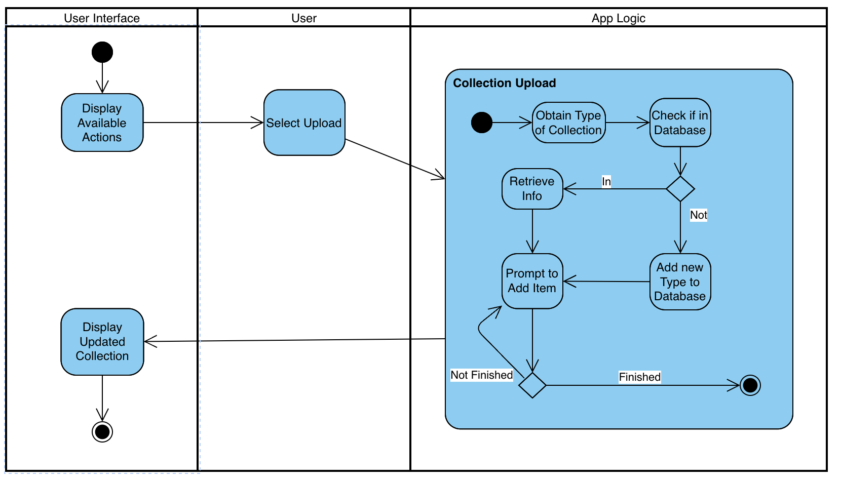

Figure 6 Upload Collection Activity

3.3.1.4.3 Associated Functional Requirements

The following functional requirements are associated with the "Upload Collection" use case:

3.3.1.4.3.1 Users **shall** have the capability to create and manage collections of items within their profiles.

3.3.1.4.3.2 The system **shall** provide a user-friendly interface for users to add items to their collections, including details such as item name, description, images, and tags for organization.

3.3.1.4.3.3 Users **shall** have the option to verify the authenticity of their collection items, indicating their credibility to potential buyers.

3.3.1.4.3.4 Users **shall** be able to compare their collections with those of other users for reference.

3.3.1.4.3.5 Users **shall** have the ability to view their collections and collections of other users within the system.